**Play Store App Review Analysis:**

**ABSTRACT:**

Google play store is simply entertainment at our fingertips. It’s an official app store and a digital media store having enormous things to offer. Applications are either free or paid. Our team has worked on play store data which has two datasets, first contains basic information of apps and other is user reviews data. This information can be used for predicting key factors responsible for app engagement & success story.

## INTRODUCTION:

Play store is not just an app store, it’s a platform offering various digital content to its consumers.

The Google Play Store is home to android applications, music, movies, books, games and television programs. 81% of the apps are free of cost which has led to immense popularity of this platform. As per google survey report 3000+ apps are being added every other day. The Google Play Store contains applications for the Android system only. This document reveals the dynamics of the Play Store app and gives actionable insights for the developers to work on and rule the Android market.

## INTEGRAL METHODOLOGY:

## First, we investigated some basic information of our dataset. On doing so we found out that our data needed some cleaning, some values were missing, and some datatypes were incorrect. We started with data cleaning and correcting the data types, followed by data visualization. We removed some unnecessary features and made it ready for analysis using different plots.

**DATASET DESCRIPTION:**

* 1st dataset has 13 features and 10841 observations. Which are as:

| App | Name of the App |
| --- | --- |
| Category | Category under which it falls |
| Rating | Application’s rating on playstore |
| Reviews | Number of reviews of the app |
| Size | Size of the app |
| Installs | Number of Installation of the app |
| Type | Whether the app is free or paid |
| Price | Price of the app if it’s a paid app (0 if it’s a free app) |
| Content Rating | Appropriate target audience of the app |
| Genres | Genres under which the app falls |
| Last Updated | Date when the App was last updated |
| Current Version | Current version of the App |
| Android Version | Minimum android version required to support the App. |

* 2nd Dataset contains 5 features and 64295 observations. Which are as:

| App | The name of the application. |
| --- | --- |
| Translated Review | Review texts in English |
| Sentiment | View or opinion of users which can be Positive, Negative or Neutral. |
| Sentiment Polarity | Sentiment in numerical form ranging from -1 to 1. |
| Sentiment Subjectivity | Measure of the expressions of opinions, evaluations, feelings and speculations. |

## BREAKDOWN OF DATASETS:

Before proceeding to data visualization, we need to perform the following steps:

1. Importing required packages for future analysis.
2. Mounting drive and reading data files from Google drive.
3. Removing future warnings in seaborn plots.
4. Viewing all data information.
5. Dropping duplicates.
6. Removing special characters
7. Checking unique values, null count and datatypes of each column.
8. Segregation of numerical and categorical data.

## EXAMINING NULL / MISSING VALUES:

Some values in our dataset are null or missing. These values affect the accuracy and performance of the models that predict the outcome, so these need to be handled. While analyzing our dataset the first thing we will do is to examine the null or missing values in our dataset. This makes our result accurate. Missing values are more in Size & Rating columns as can be seen by plotting graphs. Hence several methods are used to remove these values.

## DATA CLEANING:

Data cleaning is the foremost step in any data science project. Cleaner the data, better are the results. As the proverb goes by saying “More Data beats clever algorithm, but better data beats more Data” – Peter Norvig. To begin with our data cleaning, first we remove the duplicate values. Then we remove unnecessary characters in our dataset.

After doing so we find the unique values of each column and make the necessary changes in each column like converting datatypes, removing the null and ‘nan’ values.

Lastly, we have done exploratory data analysis of our dataset.

## DATA VISUALIZATION:

# Observation 1:

We draw a boxplot to see is there any outlier present in our data.

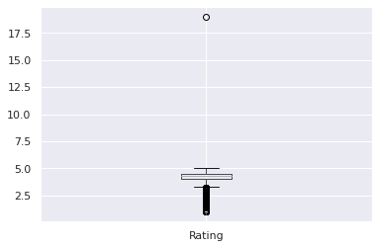

# Observation 2:

We plotted a graph of android version supported apps.

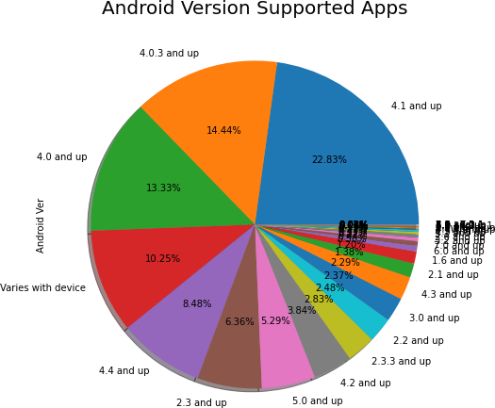

Android 4.0 and above version supported apps ratio is very high, more than 70% apps require android 4.0 version.

# Observation 3:

We plotted a graph of top categories on playstore.

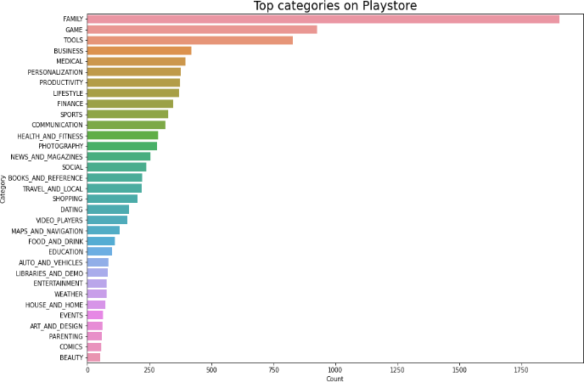

Play store market is ruled over by family and game category followed by tools, business, medical, personalization and so on.

# Observation 4:

We plotted a graph of top genres on play store.

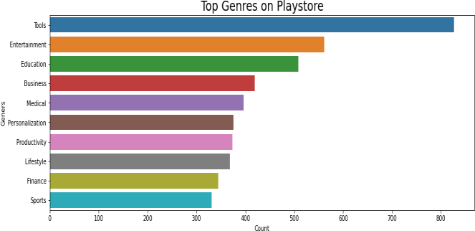

As seen in the graph, top 5 genres are - tools, entertainment, education, business, medical.

# Observation 5:

We have plotted a Pie chart to represent the percentage of different sentiments.

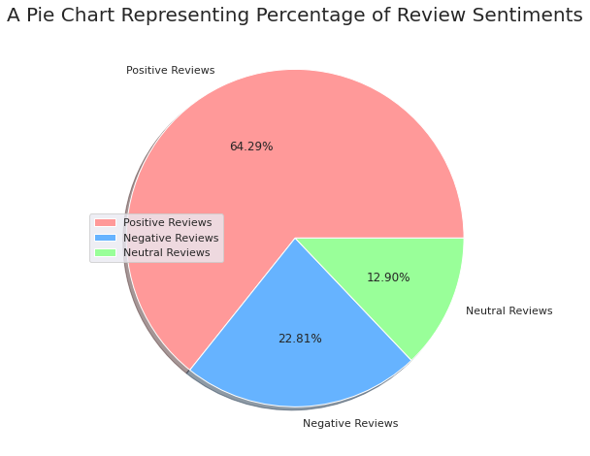

On the basis of sentiment,  **64%** are **Positive, 23%** are **Negative** and **13%** are **Neutral** values.

# Observation 6:

We plotted a graph to check the most

frequent rating of the apps.

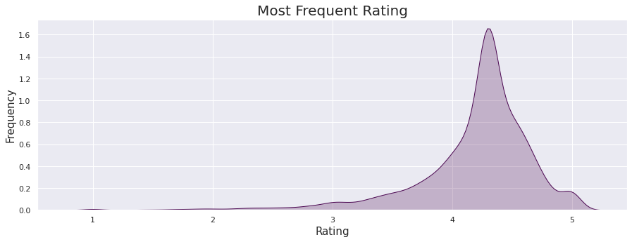

Most apps have a rating between 4 to 5(mostly 4.3 approx.)

# Observation 7:

We plotted a pie chart to obtain the ratio of paid app and free app in play Store.

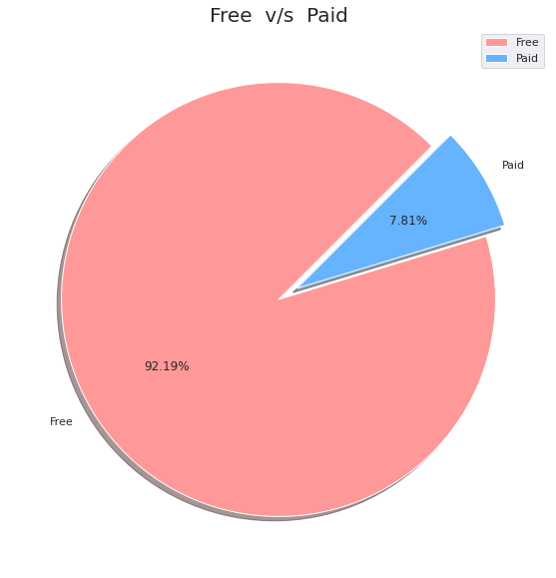

Free apps are 92.19%.

Paid apps are 7.81%.

# Observation 8:

We plotted a graph between number of apps updated and year.

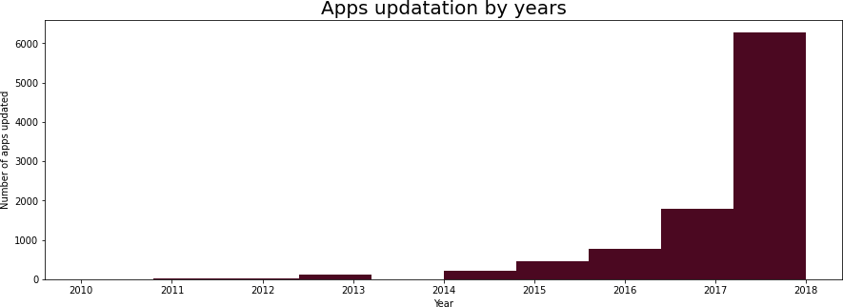

Most of the apps were updated during 2017-2018 year.

# ADVANTAGES OF VISUALIZATION:

* Visualized data is processed faster and easier.
* Better insights of the data are drawn which may be missed in traditional reports.
* Helps us visualize trends which improve performance.

# CONCLUSION AND FUTURE WORK:

The app developers can predict the outcome of the developed apps. Better insights are drawn from this visualization. Apps which need to be improved can be worked upon by the developers. The dataset contains immense possibilities to improve business values and have a positive impact.

We could add a system that would create application on its own by using the dataset and creating the best user interface by highly rated apps.

# ACKNOWLEDGEMENT:

This project is presented by:

Shreya Agrawal, Shubhangani Tiwari, Priyanshu Tiwari, Husain Bharmal, Vaibhav Lawate.

Our sincere efforts have made us accomplish the task of completing this project. We are extremely grateful to our instructors and mentors who have helped us to grow in this field. We would like to express our sincere gratitude to the celebrated authors whose phenomenal work has been consulted in our project work. We also wish to convey our appreciation to our peers who provided encouragement and timely support in the hour of need. This project helps us to improve our skills and enhance our knowledge.

# REFERENCES:

[https://seaborn.pydata.org/tutorial/color_palett](https://seaborn.pydata.org/tutorial/color_palettes.html) [es.html](https://seaborn.pydata.org/tutorial/color_palettes.html)

<https://www.python-graph-gallery.com/196-select-one-color-with-matplotlib>

[https://www.analyticsvidhya.com/blog/2021/05/10-colab-tips-and-hacks-for-efficient-use-of-](https://www.analyticsvidhya.com/blog/2021/05/10-colab-tips-and-hacks-for-efficient-use-of-it/) [it/](https://www.analyticsvidhya.com/blog/2021/05/10-colab-tips-and-hacks-for-efficient-use-of-it/)